Art has been used to illustrate the imaginary and fantastical to depict feelings of awe, wonderment and intrigue since the most primitive art. Some pieces have had religious significance, others a more abstract bent, depicting the impossible, the nightmarish, the alien and the unnervingly familiar. A fantasy piece can be a portal into the mind of its creator: a world not born from the painting, but rather the reverse – it is this world which spawned the piece which has brought you to this place strange and untrue.

I have made two pieces which I feel invite the viewer to a different place. Both have been heavily influenced by the work of John Martin, and so in addition to reference to other artists, I shall also examine one of his works in comparison to each of my own.

The first piece, “Peace?” was directly inspired by Sleeping Venus by Paul Delvaux. I was intrigued by the effect of the clean street and grand, ancient buildings lit under a night sky. The effect should have been impressive and majestic, but was instead overbearing and cold, dominated by grand mountains and populated by vulnerable nudes and the strange figures of a skeleton and mannequin, unnaturally posed.
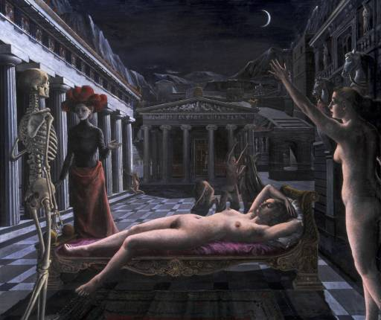
Fig 1. Sleeping Venus, Paul Delvaux

Although I wanted to draw on different themes to those presented in Sleeping Venus, I hoped to keep the mood of the piece similar, but with a heightened sense of isolation. I began by sketching in pencil how I wanted the piece to look. My initial drawing contained all of the elements that I would ultimately include, though the composition was slightly different.
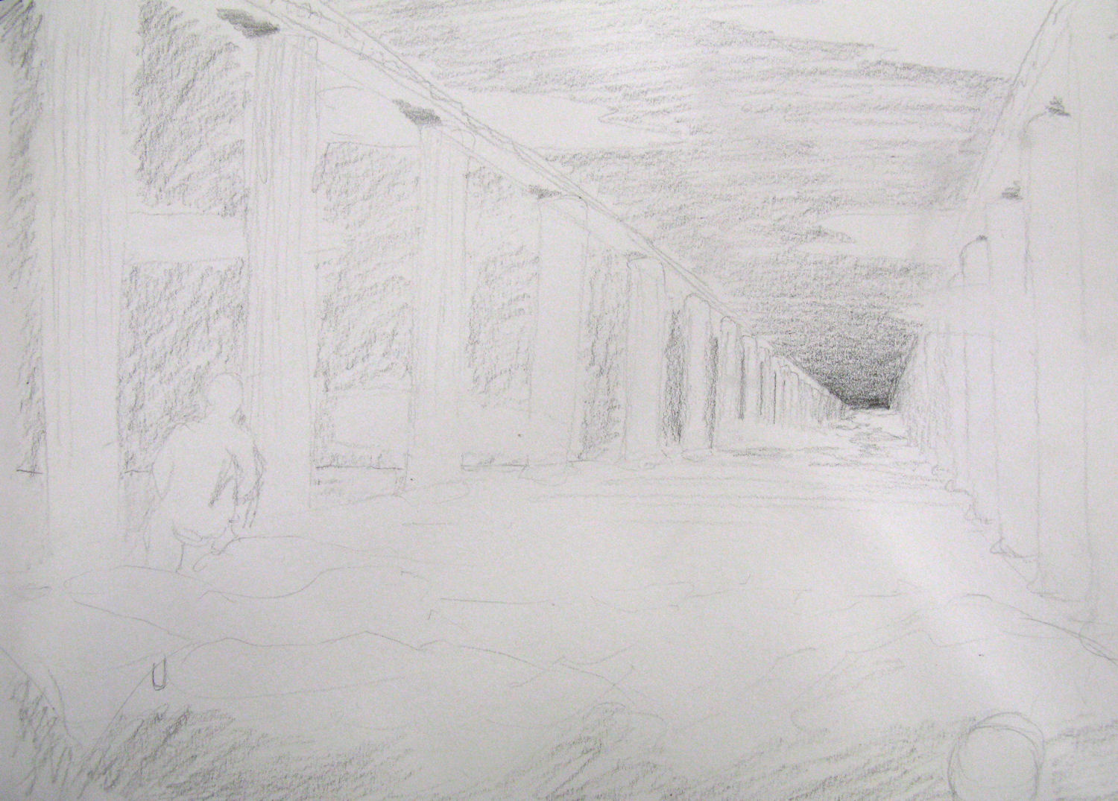
Fig 2a. Peace? Initial sketch

The piece approaches the idea of life after death by examining Christian beliefs and encouraging the viewer to question them. It is a vehicle for the belief that in death, all is at an end and there is absolute nothingness. The content was imagined entirely as a whole as a distortive fantasy piece. I hoped the piece would draw viewer’s into pondering a topic which I feel is largely unconsidered, but that ought to have a significant impact on the viewer’s outlook.
The final piece, which took around 5 hours in three sessions, used charcoal on white paper to create a visually high-contrast and unambiguous feel in the piece. The work was done on a well-lit, flat table to prevent loose charcoal falling down the piece. After an initial under-drawing to confirm compositional elements, a fine stick of charcoal was used so that detail could be added with the edge of the tip and tonal work could be done using the flat of the tip. Some areas were softened by pushing and brushing the loose charcoal with a finger, creating smoother tone gradients. A putty rubber was used to remove unwanted charcoal as well as to add highlights. The piece made use of accurate drawing, an understanding of anatomy and pose, and use of perspective to create depth.
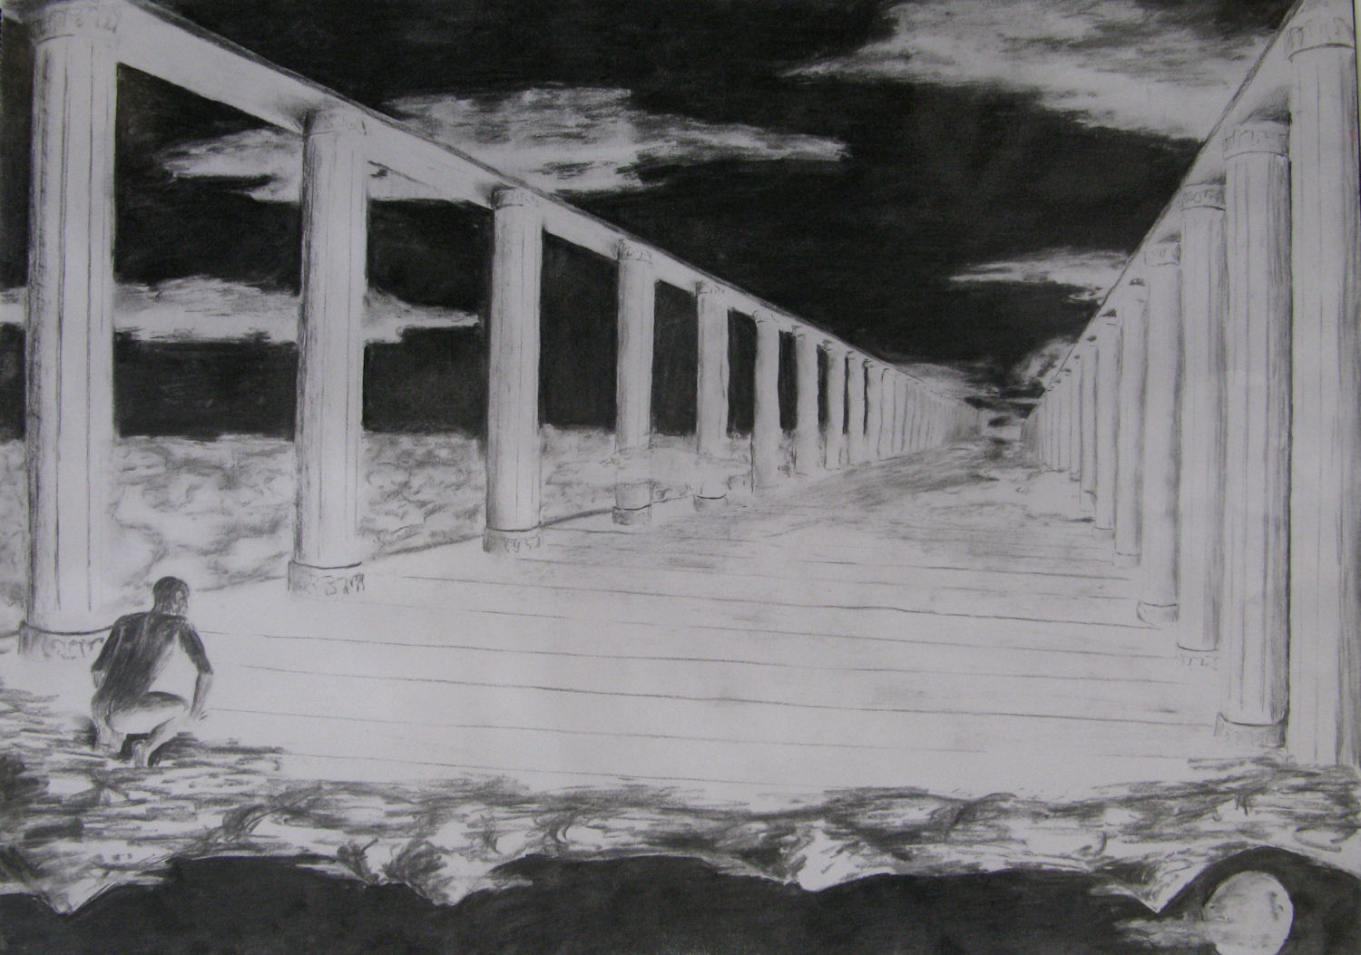
Fig 2b. Peace?

The title of the piece refers to the well-known Catholic epitaph “Rest in Peace” and alludes to the Christian ideology of a peaceful heaven. The piece however, turns this belief on its head and considers the more frightening possibility of the afterlife. The figure was not carried up to pearly gates, and welcomed by a host of angels, but rather seems to have crawled up to an endless expanse of emptiness.

While initially the bottom section of the piece seems to be the sky beneath the heavens above, on closer inspection a familiar and natural moonscape rests hanging upside-down from the heavens. Turning the piece literally on its head, what the viewer had assumed to be the heavens on high is now a world beneath our feet, populated with emptiness. Ours is the world above, and theirs a cold and barren endlessness.

The light in the piece comes from below; while at first glance this gives the impression of glowing brilliance, it soon begins to look most peculiar. The strength of the light, shown by the strong shadow on the back of the visitor, is dazzling and not gentle. It illuminates the clouds from below, something only seen at dawn and dusk, and given the night-time environment, becomes quite unnatural. There is an even balance of dark and light tone which heightens the sense of clarity – there are no subtle suggestions of form hidden in the dark or barely visible in the bright, all is clear for the viewer to see far into the distance.

The composition of the piece is deliberately awkward – the horizon is just a little above the halfway mark and the focus point is a little right of the natural third. These features have the effect of not allowing the eye to rest comfortably. In addition, nothing draws the viewer’s attention to the bottom of the piece, which gives a sense of uncomfortable discovery when the viewer looks at it, emphasising the meaning behind the bottom section. All elements in the composition point towards a single focus point, particularly the line extending from the visitor’s gaze. This point, seemingly infinitely far away, but rather than the lines converging upon it, it has been left open. The viewer seems able to confirm that even a great distance away, all is quiet and empty.
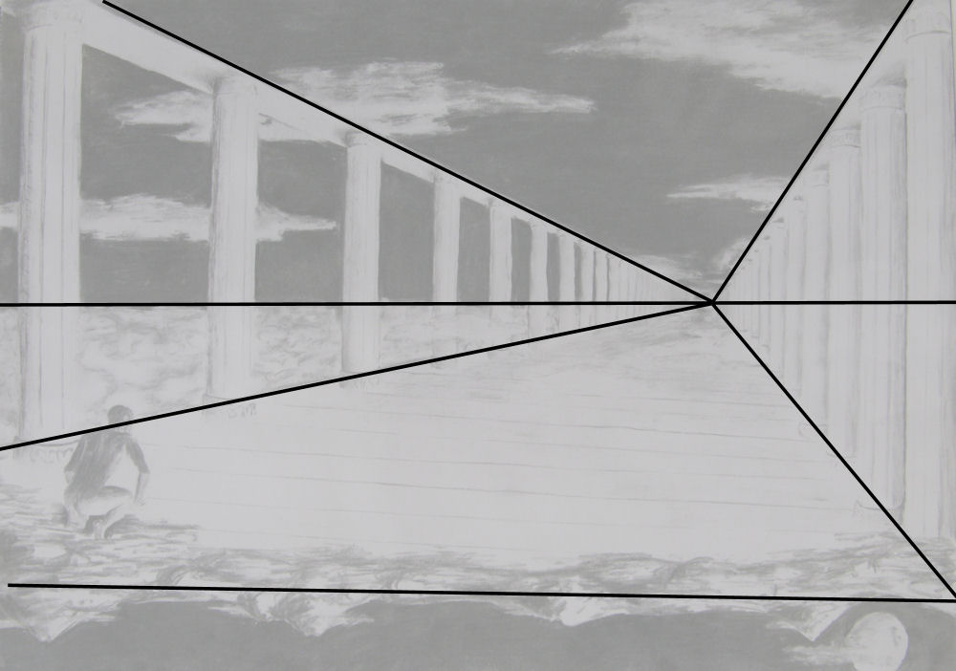
Fig 2c. Compositional diagram

The stillness of the piece is reconfirmed by the wispy clouds that seem to be drifting about this world, undisturbed by even a breeze. The loneliness created by this scene draws in part from the poem I Wandered Lonely as a Cloud by William Wordsworth, although the joy of the daffodils Wordsworth writes of is distinctly absent in my piece. Absent, in fact, is colour entirely, exposing the lack of life’s vibrancy and emphasising the starkness of the piece. The sharp tonal contrast used together with the hard edges of the pillars and floor bring a disturbing clarity to the piece. There is no mistaking what the figure, and the viewer, is witnessing.
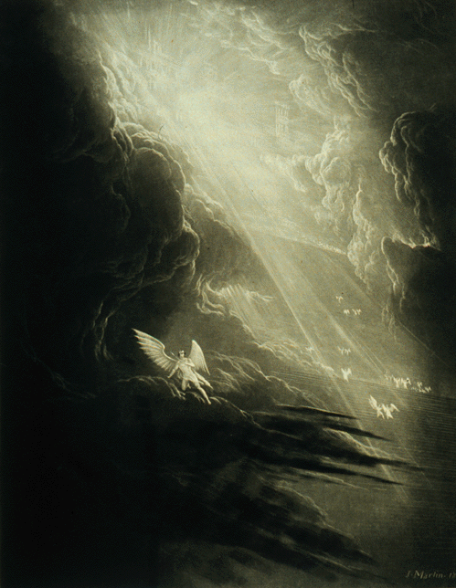
Fig 3. Illustration for Paradise Lost, John Martin
In John Martin’s illustration for Paradise Lost, a popular conception of heaven is held. Angels wait at the steps ascending to the gates of heaven to receive the souls of the dead. Martin has used a strong and brilliant light to illustrate heaven, and grand billowing clouds which part on the path toward heaven. He has made much more use of dark tones in order to emphasise the brilliance of the rays of light descending from heaven. The vibrancy of the light has two effects: immediately it adds life to the piece, but also it obscures heaven, adding to the mysticism. I, however, wanted to show a strong light but while maintaining unnerving clarity.
Martin’s focus in the piece, despite the strong light, is the angel in the foreground turning his back on heaven, and not heaven itself. By placing him among the dark clouds, a reverse silhouette is used to glorify the figure. I hoped for the reverse in my piece – a dark silhouette dirties the visitor, giving him the appearance of wretchedness and unworthiness, which is further emphasised by his crawling pose.

The subject, themes and visual techniques used in the piece cause a deliberate discomfort in the viewer. By showing the afterlife as endless and empty but presenting it in a way which plays on familiar and classical beliefs leaves a disturbing and twisted feel. This mood is likely to be deeply affecting as the questions raised by the piece come to the viewer slowly and not all at once and deal with very significant, deep-set beliefs.
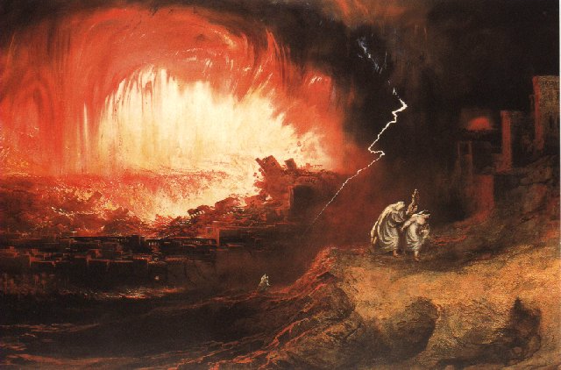
Fig 4. Sodom and Gomorrah, John Martin
For the second piece, I looked at John Martin’s The Destruction of Sodom and Gomorrah and The Great Day of His Wrath. In these later pieces by John Martin, he uses strong reds and some blues in his palette and very dynamic flames and flowing liquid to empower the destructive forces shown in the pictures.

Again, an initial sketch allowed me to explore how I wanted the piece to look. I was inspired by the scientific prediction of the sun melting and burning the earth as it becomes unstable.
“Earth will still confront its ultimate doom: a bloated, searing Sun is destined to scorch and melt the planet, wiping it clean of life.”
MALCOLM W. BROWNE for The New York Times, 20/9/94

In this piece I wanted to use symmetry to create a unity and natural beauty in the piece. On a similar theme to the first piece in this analysis, I wanted it to be less immediately apparent that the theme was destructive. To this end, I chose to use the sun and not its destruction as the focus point for the piece, and to present it as both a source of massive power and as a wondrous sight to behold. I hoped to keep much of the destruction implicit, with suggestions of the consequences at the edge of the piece.
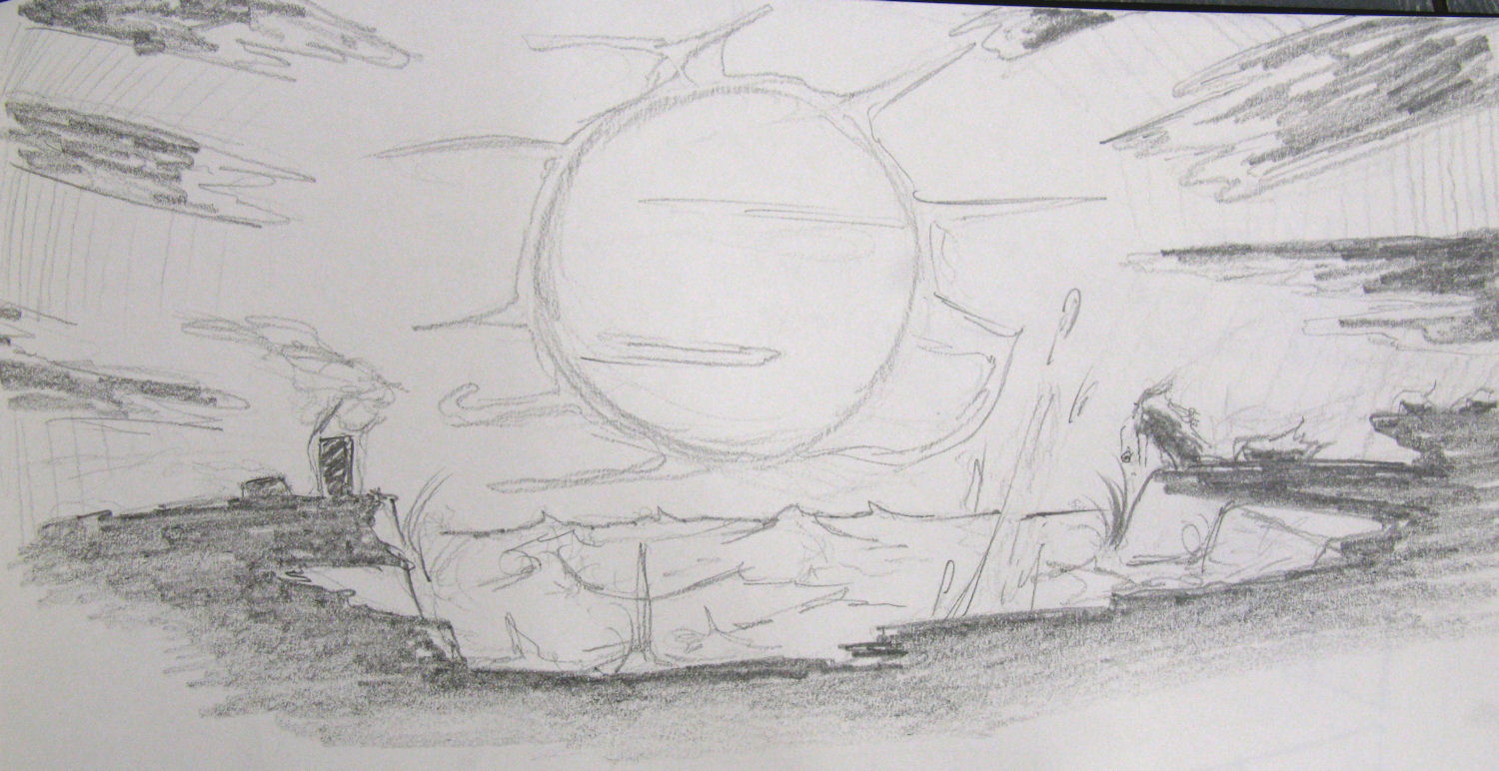
Fig 5a. Devil Sun Initial Sketch

While I was only really interested in creating a piece to demonstrate the power of nature, the apocalyptic theme is an incidental representation of many religious depictions of Armageddon. The scene was imagined as a whole and is largely representational, if somewhat sensationalised.
After an under-drawing was made to confirm compositional balance and symmetry, watercolours were built up in layers. A wash brush was used for the sky and foreground to maintain a smooth colour gradient and a smaller brush was used for the clouds and detail on the sun and sea to allow greater accuracy. After the painting had dried, black pen was used to tighten the painting up and clarify the focus across the image. The processes involved in the final piece took around 4 hours altogether and were completed on a flat table to prevent the watercolour washes from running. An understanding of colour and the watercolour material as well as accurate pen drawing skill were required for the piece.
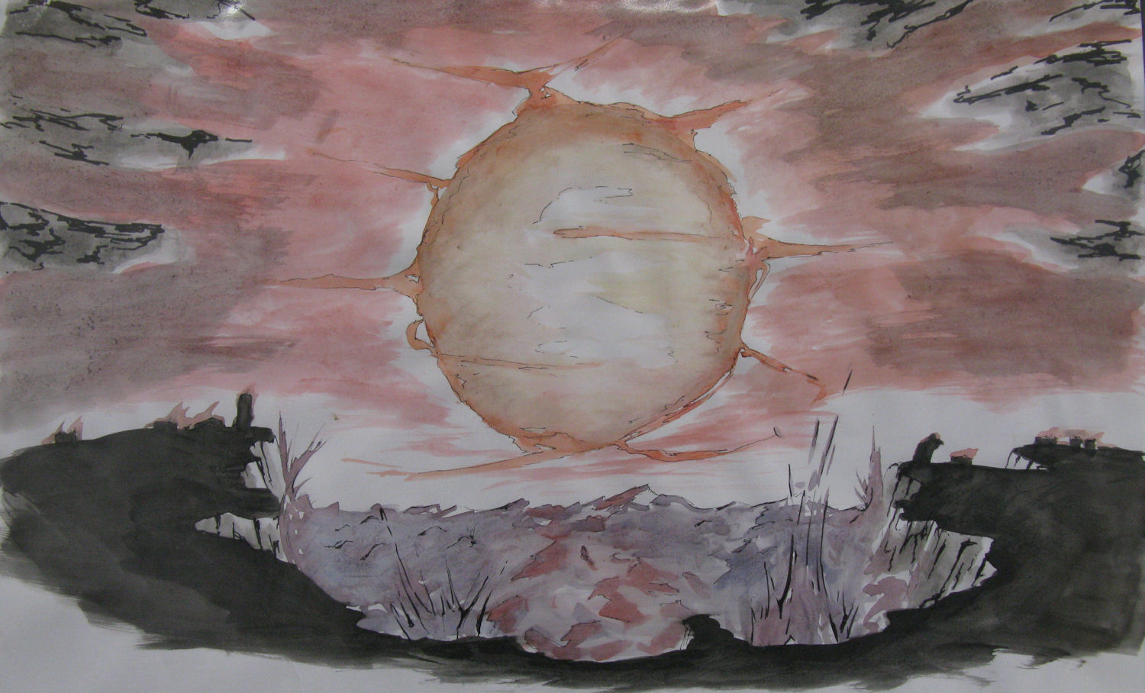
Fig 5b. Devil Sun

Compositionally, focus is drawn towards the centre of the image where a massive sun is placed. By having a broken and disrupted horizon line, additional visual aggravation is caused. Despite this, the symmetrical composition maintains a strong sense of natural beauty. The dark edging in the piece maintains the viewer’s gaze on the centre, and discourages the eye from wandering outside the painting. The sun seems to forcing back clouds, cliffs and water with its strength; all of which seem to be pushed away uniformly, conforming to the circular shape, principle to the piece. The waves smashing against the rocks, the clouds and smoke sweeping back and the tiny buildings falling burning and falling down all add to the drama of the painting.
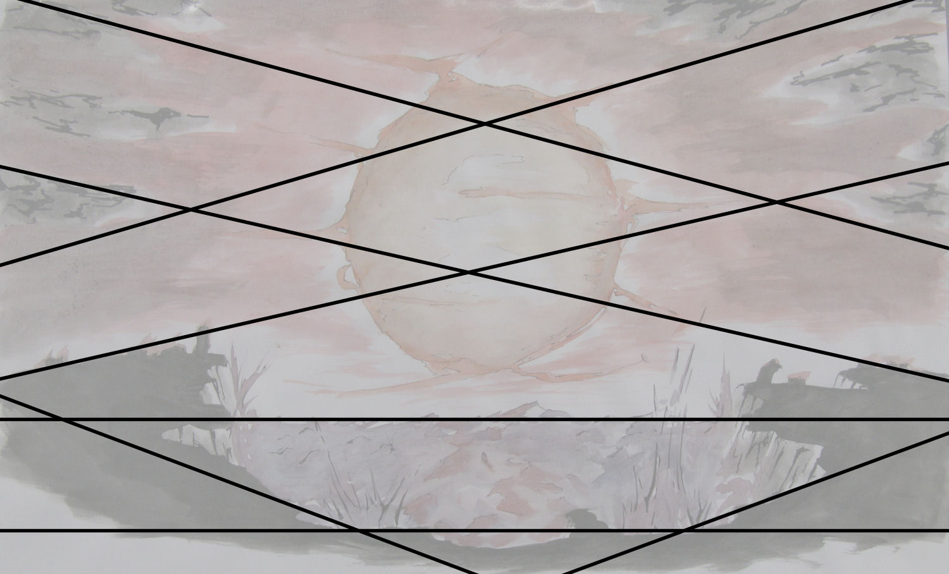
g 5c. Devil Sun Compositional Diagram

The colours used in the piece soft reds, greys and blues. The palette is more suggestive of power than it is overt in its expression, and the dulled colours are harmonious and comfortable to look at, allowing for calmer initial reactions to the piece. The black pen has been used to draw out movement in the piece – the waves crashing against the cliffs and the fiery arcs encircling the sun. Red dominates the piece, giving a clue to the theme present – while red is typically an alarming and destructive colour, the pale red used is only suggestive of such destruction.

A variety of textures has been used to separate the elements in the work – the clouds make heavy use of pen ink to separate them from the sky, which itself very washy when compared to the more descriptive and solid sea which is in turn busier than the silhouetted foreground at the front of the image. While ordinarily this mixture of textures would cause confusion, the regular and symmetrical placement of the elements in the piece help the eye to visually break apart these textures from one another, rather than become confused by them.
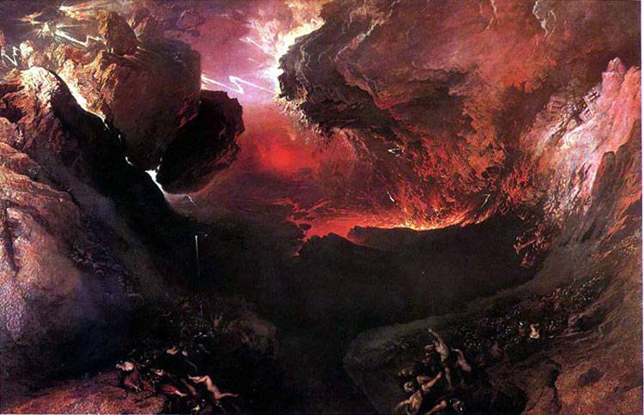
g 6. The Great Day of His Wrath, John Martin
Comparing the work to John Martin’s The Great Day of His Wrath, Martin uses much stronger colours and a busier composition to create a primal chaos and energy in the painting. It is immediately distressing to look at and the sheer energy of the piece is exploding off of the canvas. I wanted a gentler feel to the piece so as to more subtly coerce a sense of dread, and have achieved this by softening the palette and balancing the composition evenly.

The figures at the bottom of the Martin’s painting serve two purposes. Firstly, they give a scale to the piece – literally hundreds of figures can be seen trembling beneath the overwhelming and massive forces of destruction above them. Secondly, they add a familiar human element to the piece – these are people, human and ordinary. This is not a depiction of an environment alien and strange, but a frightening possibility of a world much like our own. I was able to take this theme and use it in my piece. By adding small, ordinary buildings to the cliff’s silhouette and having them falling apart and burning to the ground, I was able to create the same dual element to my piece.

The piece again deals with the theme of jerking initial reactions and twisting them as the viewer continues to examine the piece. By using the familiar, more deeply unsettling moods creep in and the pieces become more affecting as a result. While the first piece is entirely contemplative, the second showcases a more primitive power and the styles used in each match these themes.

